Web Services Transaction Processing
A three-part framework for business transaction processing

Authors:
Mark Little, Arjuna Technologies Limited,
Eric Newcomer, IONA Technologies
Editor:
Dave Ingham, Arjuna Technologies Limited

Abstract
Transaction processing is at the core of commerce. All businesses have the concept of a transaction, but realize the concept using various architectures. Some transactions are very simple, such as purchasing a book or transferring funds, and can be processed immediately. Other transactions are more complex, such as fulfilling a purchase order or completing an insurance claim, and may take days or even years to process. Transaction processing forms the core of enterprise information systems and often drives the business. Once developed and proven, successful TP systems stay in place for decades.
Therefore a strong requirement exists for defining a multi-level framework capable of supporting varied transaction processing approaches, with an emphasis on interoperability to preserve existing investments.
The Web Services Transaction Processing (WS-TP) framework is divided into three parts:
- Web Service Activity Service (WS-AS), a lightweight framework for simple context management
- Web Service Coordination Framework (WS-CF), a sharable mechanism to manage context augmentation and lifecycle, and guarantee message delivery
- Web Services Transactions (WS-TXN), comprising three distinct protocols for interoperability across multiple transaction managers and supporting multiple transaction models
The parts of WS-TP are designed to support various transaction processing models and architectures. The parts define incremental layers of functionality that can be implemented and used separately by other services/specifications or together. Furthermore, the parts comprise a stack, starting from WS-AS, adding WS-CF, and finally WS-TXN to deliver complete features and functionality. An implementation can start with WS-AS for simple context management, and later add WS-CF for its additional context management features and message delivery guarantees, and finally add WS-TXN for managing a variety of recovery protocols.
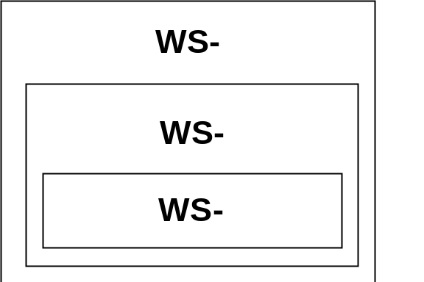

Figure 1, Logical relationship of Activity, Coordination, and Transactions
WS-TP concepts are based on the assumption that multiple individual Web services are often placed into various relationships to accomplish a common purpose and therefore at a minimum need a way to share common context, and at a maximum need a way to coordinate results into a single, potentially long-running larger unit of work.
Multiple Web services typically cooperate to perform a shared function, such as multiple related operations on a shared resource such as a database or display, or processing different portions of a purchase order using a predefined sequence. Cooperating Web services may be co-located or remotely accessed.
Cooperating Web services are called participants in a transactional unit of work. Participants are minimally identified as Web services that share a common context. A context is a data structure containing information pertinent to the shared purpose of the participants, such as the identification of a shared resource, collection of results, common security information, or pointer to the last-known stable state of a business process.
One of the main benefits of sharing context is that all participants can discover the result of the execution of the overall cooperating unit of work, or scope of the shared function. In many cases, depending on the success or failure of one or more of the participants, other participants may want to be notified or even directed to perform specific actions. Tracking execution results (i.e. success or failure), notification of results, and ensuring a common outcome upon failure are other ways to describe the WS-AS, WS-CF, and WS-TXN layers.
One of the main benefits of a coordinator is that it can take the responsibility for notifying the participants of the outcome, persisting the outcomes of the participants, and managing the context. The outcome summarizes the results obtained by executing the cooperating Web services, and outcome-based behaviours are be defined using various protocols.
A coordinator becomes a participant when it registers itself with another coordinator for the purpose of representing a set of other, typically local participants. When a coordinator represents a set of local participants, this is called interposition. Interposition assists in achieving interoperability because the interposed coordinator can also translate a neutral outcome protocol into a platform specific protocol.
The main benefit of adding transaction-based protocols is that the participants and the coordinator negotiate a set of agreed actions or behaviours based on the outcome, such as rollback, compensation, three-phase commit, etc.
Using the Activity Service, Web services can manage and interpret shared context themselves, or optionally, depend upon a shared Web service with which they each interact to manage and interpret the context. Using the Coordination Service, Web services register with an external service that takes responsibility for managing and interpreting the shared context, and coordinating the notification messages sent to participants upon completion of the shared work. Using the Transaction Service, the Coordinator can coordinate completion activities depending upon the outcome of the shared work and the selected transaction model.
WS-TXN supports three transaction models:
- Basic (familiar two-phase commit) with interoperability across multiple transaction managers.
- Extended (including asynchronous coordination and compensation) for long running and asynchronous transactions.
- Business process, for treating all steps in an automated business process as part of a single logical transaction.
These transaction models can be used separately or in combination to support a wide range of business transactions from small, quick updates to long running business processes.

Comparison with other specifications
Other specifications have been published in the area of Web services transactions. In contrast to the other specifications, the WS-TP framework:
- Provides a basic mechanism for context sharing and defines the context as a Web resource that can be independently implemented
- Defines a neutral, abstract transaction protocol for mapping to existing implementations
- Models transactions at three levels of abstraction to fit different types of business transactions
- Layers technology appropriately from basic to complex functionality for ease of implementation and use, allowing implementations to start simple and move to complex as appropriate and necessary
- Achieves broad interoperability through the use of neutral protocols and interposition
The WS-TP framework can use any transaction protocol in place of or in addition to the neutral protocol defined for WS-TXN. WS-TP does not require the implementation of a new transaction protocol. Rather, WS-TP decomposes the problem into appropriately sized layers and allows implementations to implement part or the entire framework.

Positioning the parts
The three parts of the WS-TP framework comprise a stack of functionality, supporting transaction processing concepts and capabilities from the simple to the complex. For example, each participant in an Activity has the ability to discover the results of the other participants’ execution and take appropriate action. Adding a Coordinator guarantees that participants will be notified, and adding a transaction protocol provides a means by which the participants can negotiate with each other to take coordinated actions as the result of knowing a common outcome. In particular:
- The WS-AS part defines a very simple mechanism that allows multiple Web services to share a common context structure, and is designed to be used independently of the WS-CF and WS-TXN parts. WS-AS ensures that all Web services participating in an Activity share a common context and can exchange information about a common outcome.
- The WS-CF part defines a coordinator that provides additional features for persisting context operations and guaranteeing the notification of outcome messages to the participants. WS-CF is designed to complement WS-AS and can be used independently of the WS-TXN part.
- The WS-TXN part defines a transaction protocol for ensuring that a common outcome is negotiated with all participants. While WS-CF is responsible only for notifying the participants of the outcome, WS-TXN defines a protocol for the participants to coordinate outcomes with each other and make a common decision about how to behave, especially in the case of failure.
The following diagrams illustrate the relationships between the parts of WS-TP.
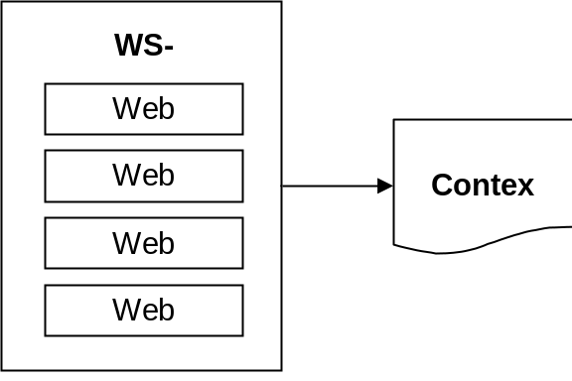

Figure 2, Activity service.
Figure 2 illustrates WS-AS as comprising one or more Web services participants that share a common context. The context is modelled as a Web resource and is accessible via URI. Web services are identified as participants in the activity by including the context URI in the SOAP header, as shown in the following example:

<env:Envelope xmlns:env="http://www.w3.org/2002/12/soap-envelope">
<env:Header>
<n:Activity xmlns:n=”http://example.org/Activity”>
<n:Context>
http://example.org/contextURI
</Context>
</n:Activity>
</env:Header>
<env:Body>
<m:Message xmlns:m=”http://example.org/MessageSchema”
<m:…
</m:Message>
</env:Body>
</env:Envelope>

Example 1, Including the context URI in the SOAP header
Web services can also choose to join an Activity upon receipt of a SOAP message containing the context URI in the header, or, optionally, containing the context itself within the body of the SOAP message.
An Activity Service is modelled as a Web service that can be co-located with the participants or executed as a separate service. All Web services referencing the same context URI, or accepting the same context in a SOAP message, are considered part of the same Activity. An implementation may permit the Web services to manage the context themselves, or use a separate service to manage the context. Context is defined as a Web resource, accessible via dereferencing the URI and can be passed by reference as a URI in a SOAP header or by value within the SOAP body.

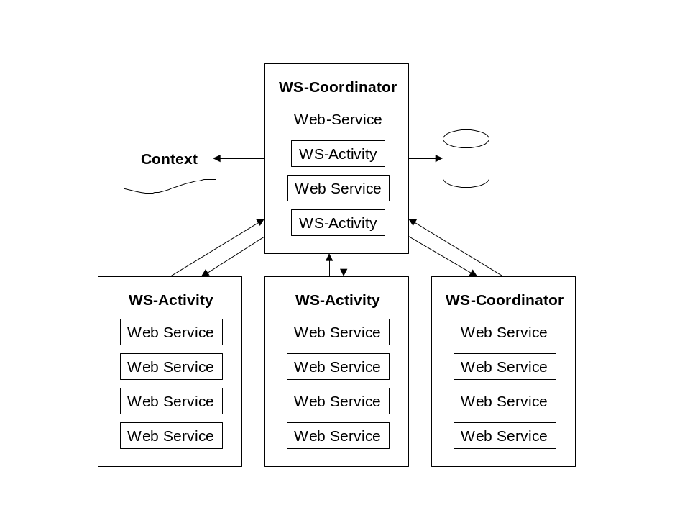
Figure 3, Relationship of coordinator to activities.
Figure 3 illustrates how activities can register as participants with a coordinator, which takes over responsibility for context management and notifying participants of the outcome of a series of related Web services executions. The executions are defined as related when they share a common context. As the illustration shows, a coordinator can register itself with another coordinator and become a participant, thereby improving interoperability. Individual Web services can also register themselves with the coordinator and therefore join the unit of work.

The following example illustrates the use of a coordinator URI reference in the SOAP header:

<env:Envelope xmlns:env="http://www.w3.org/2002/12/soap-envelope">
<env:Header>
<n:Activity xmlns:n=”http://example.org/Activity”>
<n:Context>
http://example.org/contextURI
</n:Context>
<n:Coordinator>
http://example.org/coordinatorURI
</n:Coordinator
</n:Activity>
</env:Header>
<env:Body>
<m:Message xmlns:m=”http://example.org/MessageSchema”
<m:…
</m:Message>
</env:Body>
</env:Envelope>
Example 2, Adding the coordinator URI reference to the message
As shown in Example 2, including a coordinator URI in a SOAP header identifies to the SOAP processor that the Web service is registering with the coordinator defined by the WSDL interface returned by dereferencing the URI.

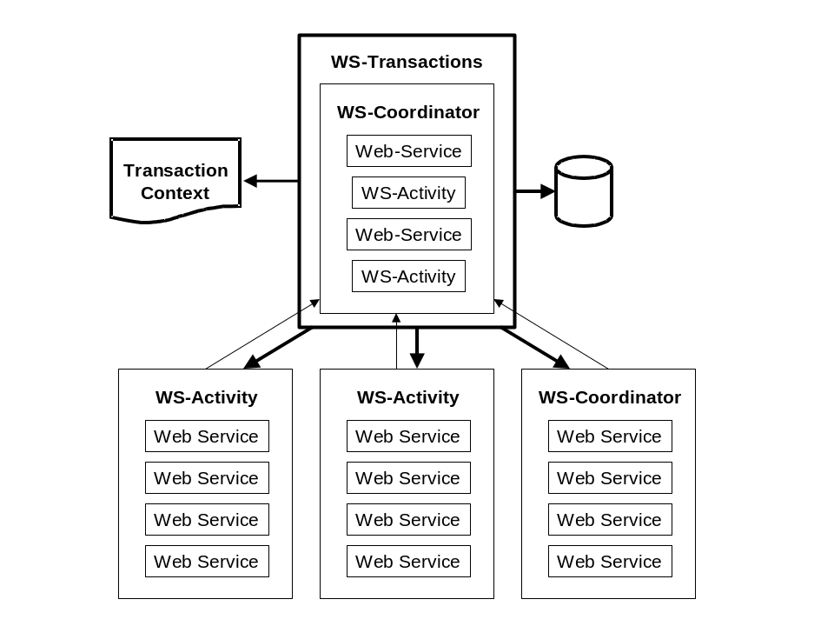
Figure 4, Relationship of transactions to coordination framework.
UPDATED TO HERE SO FAR.
Figure 4 illustrates the layering of WS-TXN onto the coordinator. WS-TXN defines a pluggable transaction protocol that can be used with the coordinator to negotiate a set of actions for all participants to execute based on the outcome of a series of related Web services executions. The executions are related through the use of shared context. Examples of coordinated outcomes include the classic two-phase commit protocol, a three phase commit protocol, open nested transaction protocol, asynchronous messaging protocol, or business process automation protocol.
Coordinators can be participants of other coordinators, as described above. When a coordinator registers itself with another coordinator, it can represent a series of local activities and map a neutral transaction protocol onto a platform-specific transaction protocol.
An activity can be a business process, or a step within a business process.

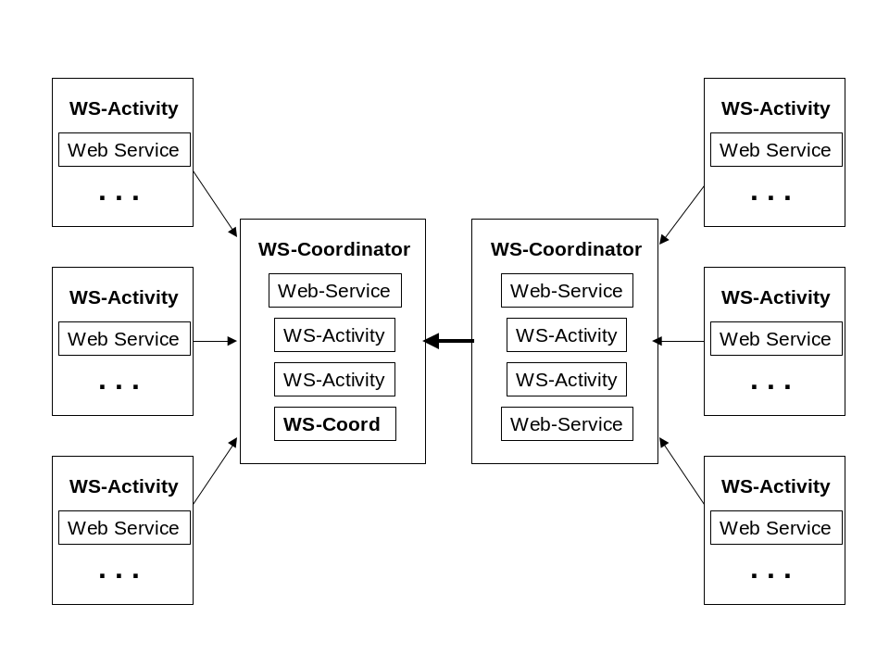
Figure 5, Interposition architecture.
As shown in Figure 5, a coordinator can register itself as a participant to another coordinator. This architecture is called interposition, and allows a coordinator to map represent a series of local activities as a single unit by coordination the local activities and sending and receiving single messages with the other coordinator.

Context
The purpose of a context is to allow multiple individual Web services to enter a relationship by sharing certain common attributes as an externally modelled entity. Typical reasons for Web services to share context include:
- Common security environment – multiple Web services execute within a single authentication session or authorization check
- Common outcome negotiation – multiple Web services or activities execute within a single transactional unit of work whose outcome must be coordinated
- Common access to such resources as database management systems, files, queues, and displays such that multiple Web services can share a connection
- Participation in an automated business process execution, or choreography
The definition of a context is application specific, but contains at a minimum a unique ID in the form of a namespace URI. The namespace URI qualifies the elements in context, which can include any or all of the following:
- Security tokens or attributes
- Transaction IDs
- File ID
- Database session ID
- Display ID
- Results for each individual execution
- Business process automation context (i.e. document or schema)
The outcome of a coordinated activity or transaction is managed either by the activity service (using lightweight mechanisms that do not guarantee notification or persistence of the results) or by the coordinator (which does guarantee notification and persistence of the results).
An activity is distinguished from a transaction by the latter’s ability to negotiate a recovery action in the event of failure. Failure is defined as one or more of the participants returning a fault that cannot be handled by the application.

Scoping
The ability to scope arbitrary units of distributed work by sharing common context is a requirement in a variety of distributed applications, such as choreography and business-to-business interactions. Scoping makes it possible for Web services participants to be able to determine unambiguously whether or not they are in the same activity, and what it means to share context.
The context contains information, including a unique context identifier (URI), the URI of the initial requester, the URI of the ultimate provider, optional URIs of each additional Web service within the scope of the activity, optional security information, and a status result for each Web service in the activity.
An Activity is defined as a collection of Web services that executes in a specified sequence for the purpose of carrying out multiple operations on a shared resource, such as a database, display, or XML document, in which the unresolved failure of an individual Web service execution causes the failure of the entire Activity. Any Web service execution that fails has the responsibility to notify any previously successful Web services of the failure, and terminate the activity. A failure can be resolved if the service requester includes sufficient failure recovery logic.
A Web service is identified as belonging to an activity by the inclusion of the context URI in the header and optionally a namespace URI identifying the list of Web services participating in the activity. The namespace URI can be translated in a variety of ways, including referencing an XML document containing the list or a WSDL serving as the interface to the list. In the case where Web services register themselves with a coordinator, the coordinator maintains the list and the namespace URI is interpreted as referencing the coordinator location.
For example:

<env:Envelope xmlns:env="http://www.w3.org/2002/12/soap-envelope">
<env:Header>
<n:Activity xmlns:n=”http://example.org/Activity”>
<n:Context>
http://example.org/contextURI
</n:Context>
<n:ActivityList>
http://example.org/ListLocation
</n:ActivityList>
</n:Activity>
</env:Header>
<env:Body>
<m:Message xmlns:m=”http://example.org/MessageSchema”
<m:…
</m:Message>
</env:Body>
</env:Envelope>

The shared context allows a series of operations to share a common outcome. The Web services participating in the Activity maintain the context information shared between multiple participants in a Web services interaction.
The first Web service invoked within an activity has the responsibility for initializing the context and updating the context with its execution result, unless the result is failure, in which case the activity is cancelled. Each subsequent Web service invoked within an Activity has the responsibility for updating the context with its execution result unless the result is failure, in which case the activity is cancelled, and any Web service execution prior to the current one is notified of the failure.
Notification in the Activity Service is accomplished using a best effort. Each Web service in the activity is responsible for invoking any recovery or compensation logic. When a coordinator is added to the picture, the coordinator takes responsibility for notifying each participant. The participants remain responsible for invoking any recovery or compensation logic. When a transaction protocol is added, the coordinator and the participants share responsibility for executing the recovery or compensation activities defined within the transaction protocol.
Transport issues aside, an important point is that context information can be specific to the type of Activity being performed, such as common operations on a shared resource, identifying a transaction coordinator, identifying the other participants in an activity, or propagating recovery information in the event of a failure.
A single context type is not sufficient for all types of Activity. Hence, the context must be extensible in an application specific manner.

